NETWORKING HOME LAB
PORTFOLIO
Hands-on configuration • Verification • Troubleshooting

Project 1 | MikroTik Routing and VLAN Lab
Project 2 | Ubuntu Server and WireGuard VPN
Project 3 | UniFi Wireless Network Integration
Project 4 | Cisco Packet Tracer Networking Labs

Prepared as a practical learning portfolio for entry-level Network Technician, IT Support, and Junior Network Engineer opportunities.
This document records practical lab work and the troubleshooting methods used. It distinguishes confirmed observations from incomplete work.

Project 3 — UniFi Wireless Network Integration
Wireless networking | Ubiquiti UniFi AP-AC-Pro and MikroTik hAP ac lite

1. Project Overview
Connected and tested a UniFi AC Pro access point on a MikroTik hAP ac lite network. Verified that the AP obtained a LAN address, responded to ping, and broadcast Wi-Fi. Also investigated UniFi management/adoption and inform communication issues.

2. Objectives
- Connect a UniFi AP to the existing router LAN and confirm link/IP connectivity.
- Access the AP for diagnostics using SSH and inspect its device information.
- Check wireless broadcasting and management/controller status.
- Understand that assigning VLANs to SSIDs requires matching AP settings and switch/router trunk configuration.

3. Network Topology
Internet → MikroTik hAP ac lite (wireless uplink/LAN) → Ethernet → UniFi UAP-AC-Pro. Windows workstation is used for ping, browser management, and SSH diagnostics. Additional SSID-to-VLAN mapping is a planned extension and must not be assumed operational.
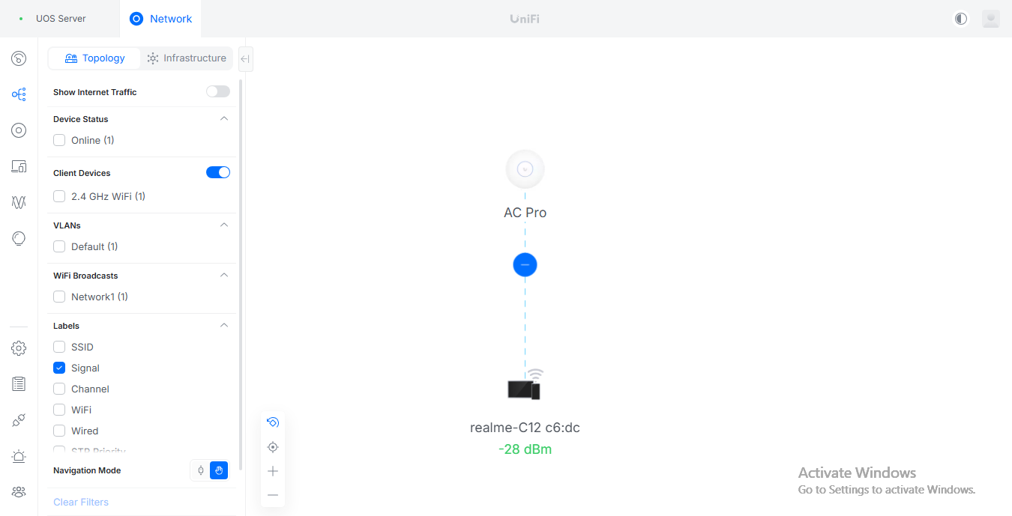

4. Configuration and Commands
The following are examples/reference commands. Adapt interface names, IPs, VLAN IDs, and device versions to the configuration you actually tested.

Windows reachability checks
ping <AP_IP>
arp -a
Test-NetConnection <AP_IP> -Port 22

UniFi AP information command (from AP SSH)
info

Controller inform URL example from this lab
http://192.168.88.254:8080/inform
Use only if this is still the correct controller address and port in your current network.

5. Verification and Testing
- Check the AP link and DHCP/IP assignment in the router or client list.
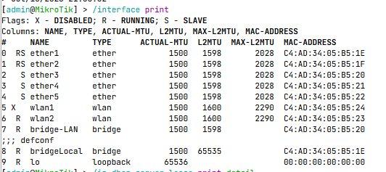
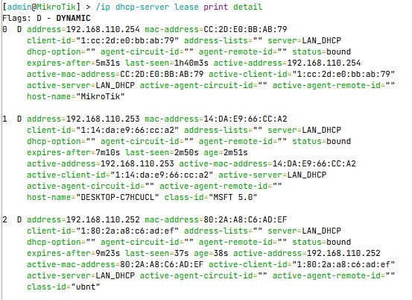
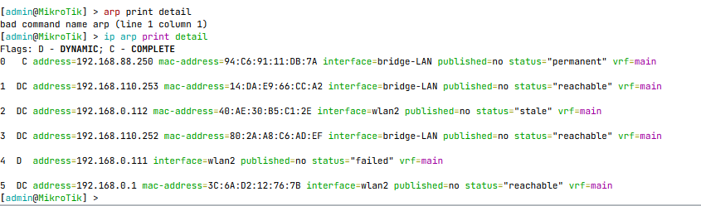
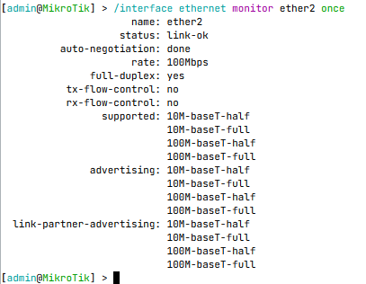

- Ping the AP IP from the Windows workstation and verify the ARP entry.
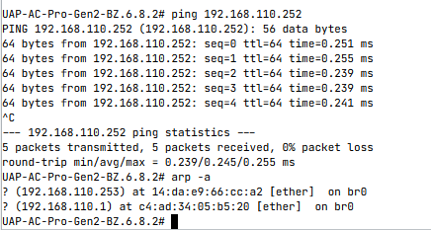
- Confirm the AP management page/status is reachable and Wi-Fi is broadcasting.
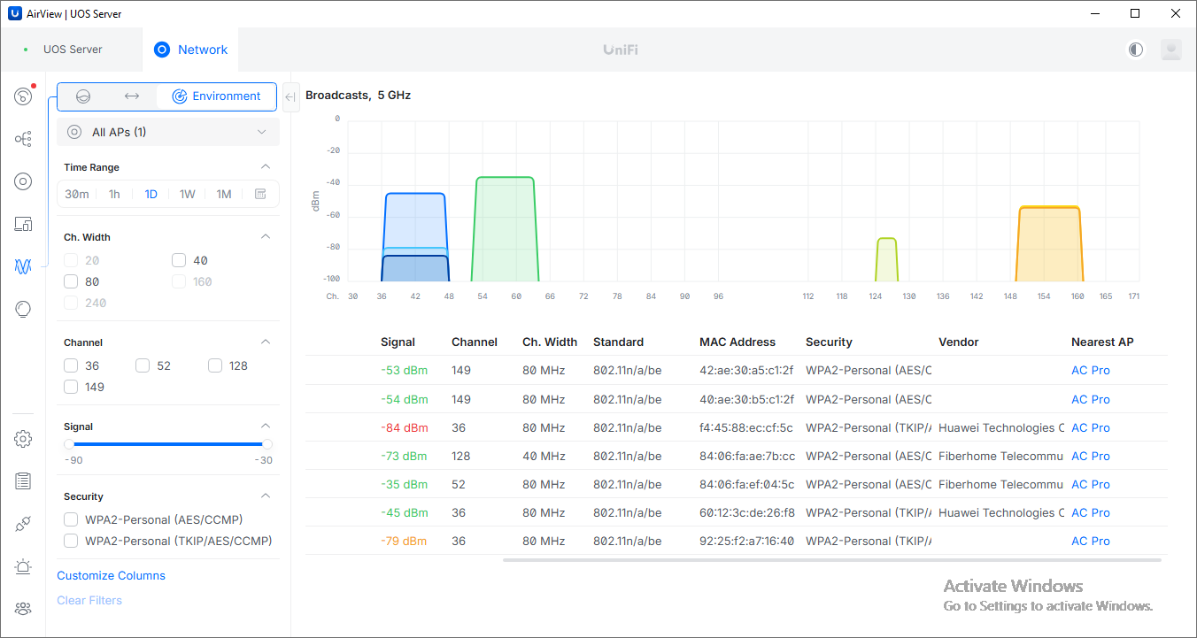
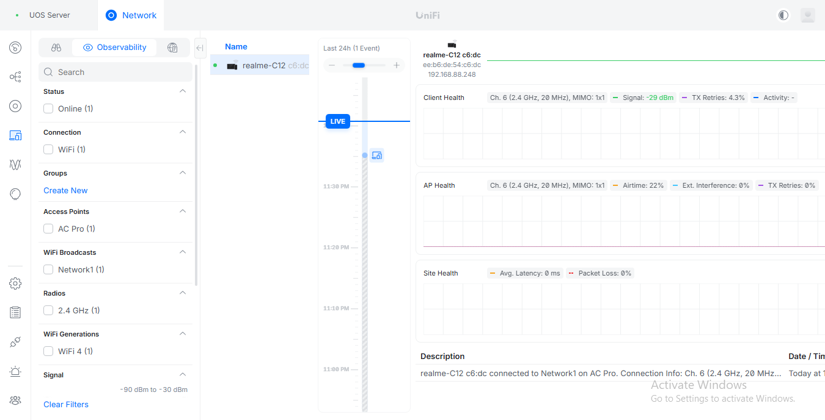
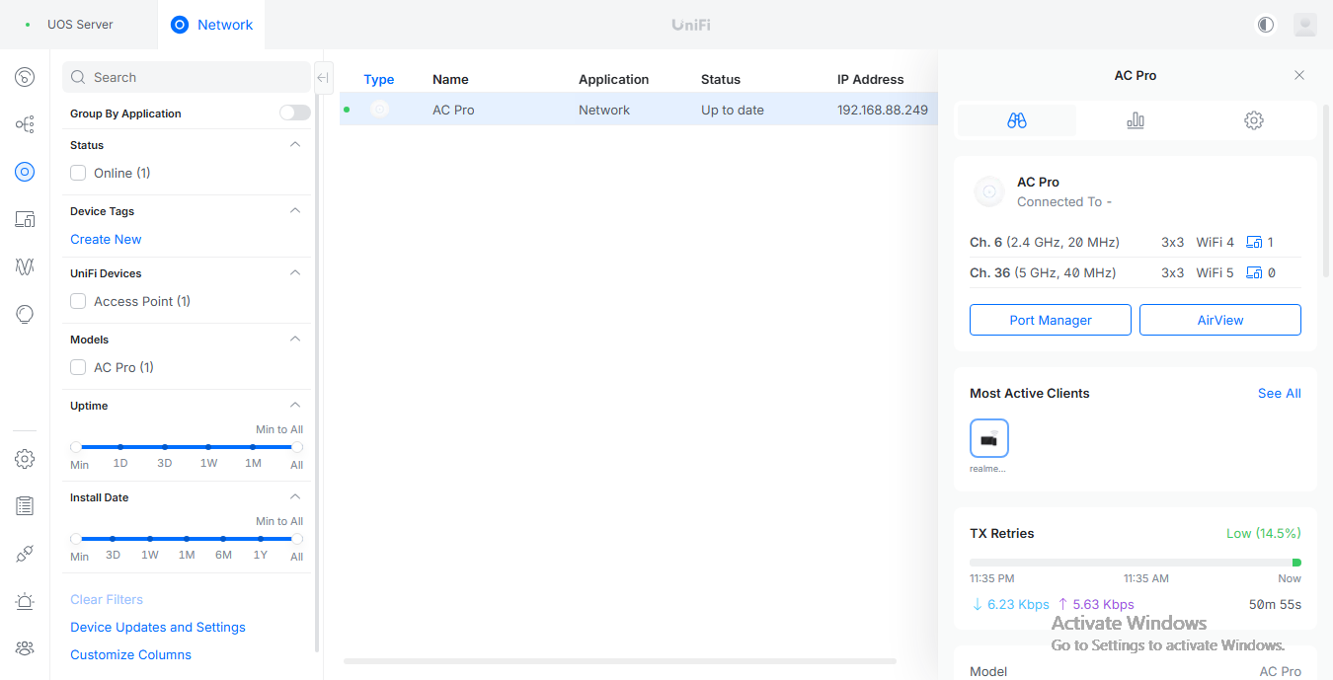
- Check controller adoption state and inform URL; verify the controller is listening on the required ports.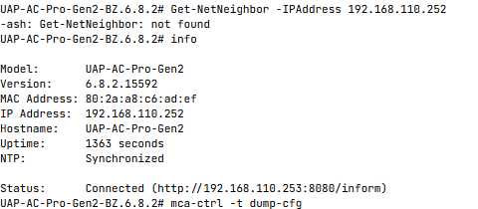
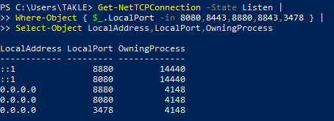
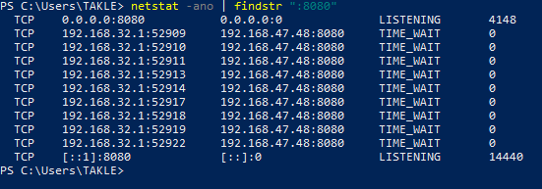

6. Troubleshooting Experience
- Verified that a UniFi AP at a 192.168.110.x address responded to ping and was reachable from the Windows workstation.
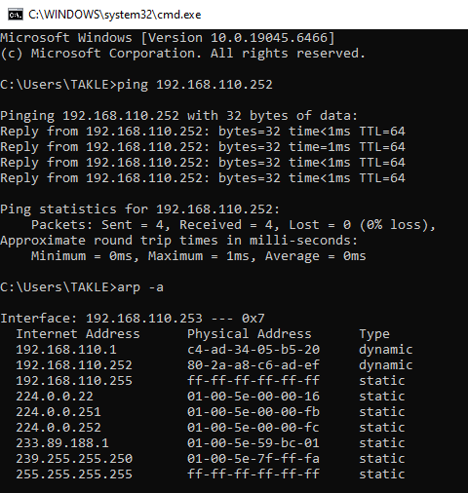
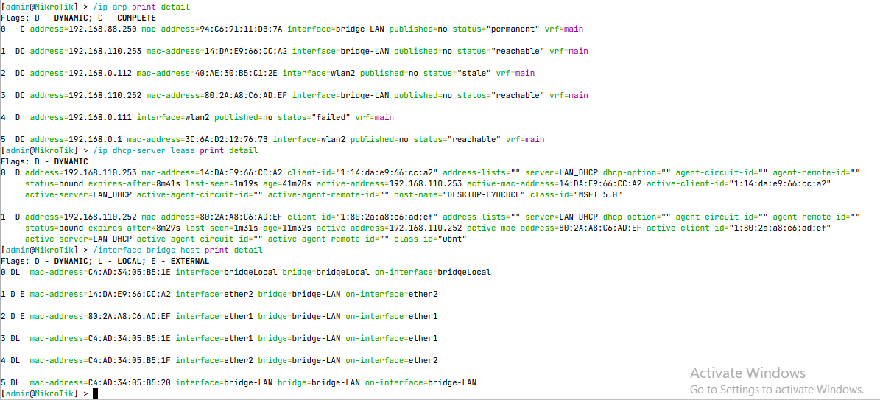
- Investigated repeated inform/decryption messages and controller adoption visibility.
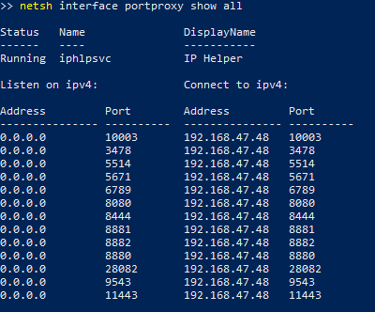

- Investigated a Windows port conflict affecting UniFi Network Server's inform port; verified the service later bound the required ports.

7. Final Result / Current Status
AP LAN reachability and Wi-Fi broadcasting were verified during the lab. Controller adoption and VLAN-backed main/guest SSID segmentation .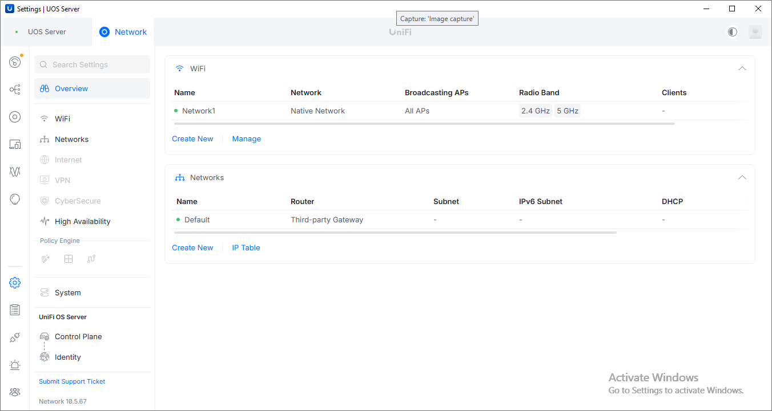
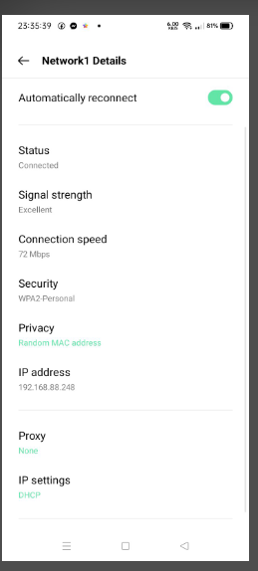

8. What I Learned
- Difference between AP IP reachability, controller adoption, and successful client traffic.
- How to use ping, ARP, SSH, device information, and controller logs together.
- SSID-to-VLAN segmentation needs consistent settings across the AP and upstream network.

9. Real-World Application
Relevant to small-office Wi-Fi deployment, AP onboarding, controller troubleshooting, and guest/main wireless separation.

10. Evidence Checklist
- Topology diagram with labels and IP/VLAN plan
- Configuration screenshot or sanitized command output
- Verification output showing successful tests
- Troubleshooting evidence: symptom → investigation → fix → retest
- Date, device/software version, and brief caption
For more information about my troubleshooting experience , you may see it to my files thank you!

